Transportation Problem Set 8 | Transshipment Model-1

Transshipment Model is a model which comes under the transportation problem. There are two types of transshipment problem:

* With sources and destination acting as transient (i.e. intermediary) nodes
* With some transient nodes between sources and destination

Look at the given transportation problem diagram.  
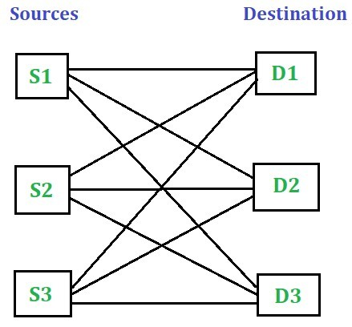  
In a transportation problem, the shipment moves from one particular source to another particular destination, maybe from S1 to D1, S1 to D2, S1 to D3, S2 to D1, S2 to D2 and so on.

This article will discuss the Transshipment problem with sources and destination acting as transient (i.e. intermediary) nodes. The next set of this article will discuss the Transshipment problem with some transient (i.e. intermediary) nodes between sources and destination.

**Transshipment problem with sources and destination acting as transient nodes**  
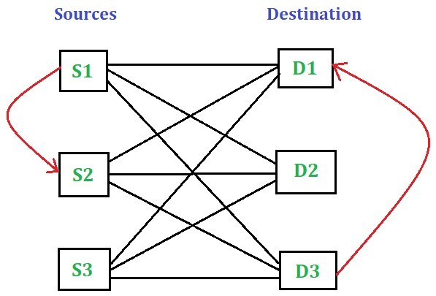  
In this method, the shipment passes through one or more intermediary node before it reaches its desired destination. This method allows the shipment to pass from one source to another source and from one destination to another destination before it reaches the desired destination.

**Note:**The intermediary nodes can be sources and destinations themselves.

Consider the following transshipment problem involving 4 sources and 2 destinations. The supply value of the sources S1, S2, S3 and S4 are 200 units, 250 units, 300 units and 450 units respectively. The demand value for destinations D1 and D2 are 600 units and 600 units respectively. The transportation cost per unit between different sources and destinations are summarized in the following table.  
Solve the transshipment problem.  
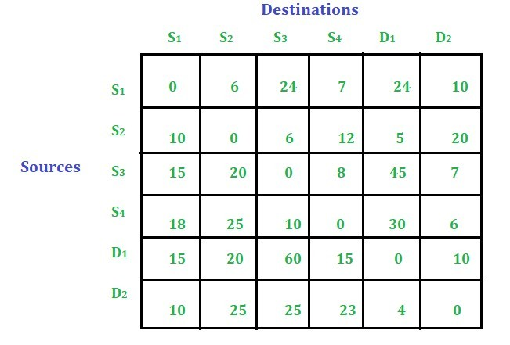

Steps to solve the transshipment problem:

* Check whether it is balanced or unbalanced. Balanced, if Total sum of supply = Total sum of demand = B so the B value here is 1200.  
  In this case the problem is balanced see the table below. In case the problem were not balanced we could add dummy row or column to make it balance.   
  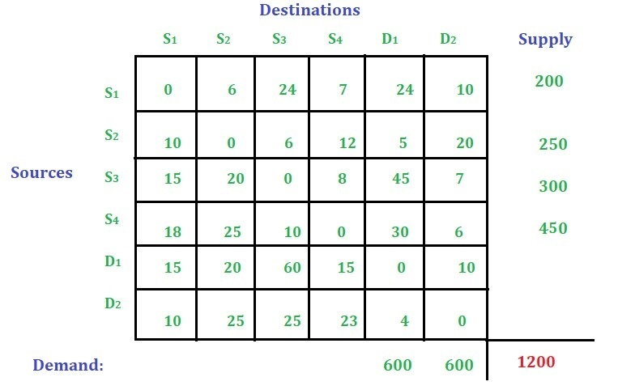
* Add the value of B to all rows and columns. See the table below:  
  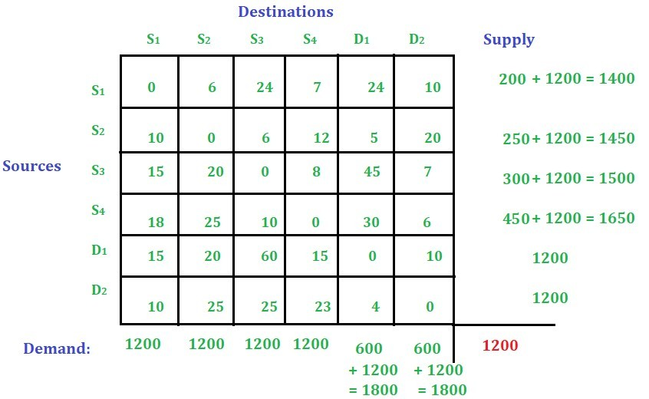
* Find out the total transportation cost using [Vogel’s Approximation Method](https://www.geeksforgeeks.org/transportation-problem-set-4-vogels-approximation-method/) as it gives the optimized solution than [Least Cost Cell Method](https://www.geeksforgeeks.org/transportation-problem-set-3-least-cost-cell-method/) and [North West Corner Method](https://www.geeksforgeeks.org/transportation-problem-set-2-northwest-corner-method/).  
  After solving the transportation problem using [Vogel’s Approximation Method](https://www.geeksforgeeks.org/transportation-problem-set-4-vogels-approximation-method/), we get the following solution,  
  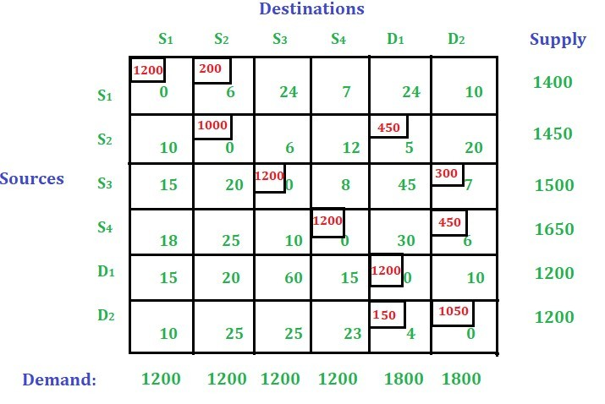  
  Just ignore the zero cost cells and calculate the transportation cost.  
  Total transportation cost is : (200 * 6) + (450 * 5) + (300 * 7) + (450 * 6) + (150 * 4) = 8850
* Draw the shipping pattern. Note: The allocations in the main diagonal cells are to be ignored.  
  To draw the shipping diagram first draw the four sources and two destinations as shown below:  
  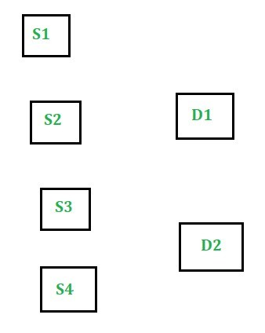
  + Look the table above the first allocated cell is (S1, S2). The first shipment starts from S1 to S2. The allocated value is 200.  
    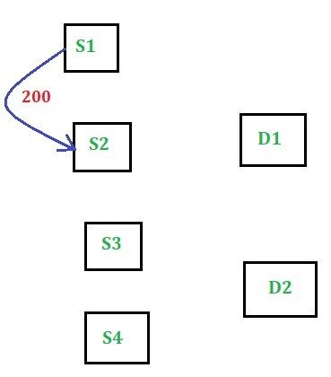
  + The second allocated cell is (S2, D1). The shipment moved from S2 to D1. The allocated value is 450.  
    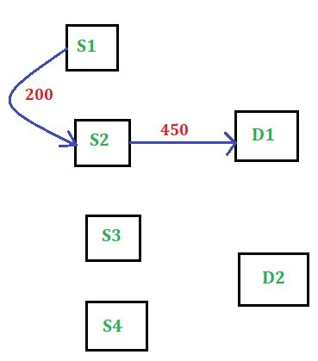
  + The next allocated cell is (S3, D2) and after that we have (S4, D2). The allocated value for these two cells are 300 and 450 respectively.  
    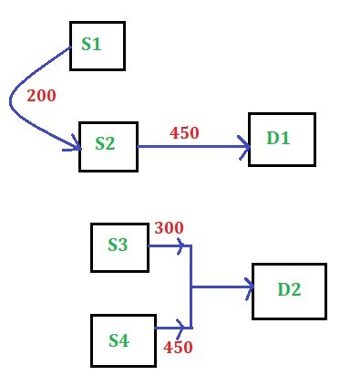
* The next and last allcoated cell is (D2, D1). The shipment moved from D2 to D1. The allocated value for this cell is 150.  
  